DEVELOPMENT OF A MULTIMODAL DEEPFAKE DETECTION: A SCALABLE AI PIPELINE COMBINING AUDIO-VISUAL ANALYSIS
Project report in partial fulfillment of the requirement for the award of the degree of Bachelor of Technology
In Computer Science and Engineering (Internet of Things, cyber Security, BlockChain Technology)

Submitted By:
Faishal Abrar Enrolment No. 12023002029050
Indrajit Mondal Enrolment No. 12023002029056
Adrija pal Enrolment No. 12023002029008
Arunavo Bhowal Enrolment No. 12023002029023
Kislay Bhardwaj Enrolment No. 12023002029042
Deepjyoti Bhattacharya Enrolment No. 12023002029043
Imon Chakraborty Enrolment No. 12023002029055
Debrup Chakraborty Enrolment No. 12023002029041
Gairick Purakayastha Enrolment No. 12023002029127
Subhradwip Das Enrolment No. 12023002029147

Under the guidance of:
Prof. Sangita Dutta and Prof. Dr. Arijeet Ghosh
University of Engineering & Management, Kolkata
University Area, Plot No. III – B/5, New Town, Action Area – III, Kolkata – 700160.


CERTIFICATE
This is to certify that the project titled DEVELOPMENT OF A MULTIMODAL DEEPFAKE DETECTION: A SCALABLE AI PIPELINE COMBINING AUDIO-VISUAL ANALYSIS by the student of University of Engineering & Management, Kolkata who are mentioned above , in partial fulfillment of requirement for the degree of Bachelor of Computer Science and Engineering (Internet of Things, cyber Security, BlockChain Technology), is a bonafide work carried out by them under the supervision and guidance of Prof. Sangita Dutta and Prof. Dr. Arijeet Ghosh during 5th Semester of academic session of 2025-2026. The content of this report has not been submitted to any other university or institute. I am glad to inform that the work is entirely original and its performance is found to be quite satisfactory.

______________________________
Prof. Sangita Dutta
Associate Professor
Dept of CSE(IOT,CS,BT)
UEM Kolkata

______________________________
Prof. Dr. Arijeet Ghosh
Associate Professor
Dept of CSE(IOT,CS,BT)
UEM Kolkata

______________________________
Prof. Sandip Mondal
HOD, Dept of CSE(IOT,CS,BT)
UEM Kolkata

ACKNOWLEDGEMENT
We would like to express our heartfelt gratitude to everyone who supported and guided us throughout this project. First and foremost, we extend our deepest thanks to Prof. Sangita Dutta and Prof. Dr. Arijeet Ghosh of the Department of CSE (IoT, CS, BT), University of Engineering & Management, Kolkata, for her insightful guidance, encouragement, and patience, which played an essential role in shaping the project’s direction. Her mentorship has been invaluable, and we feel truly fortunate to have worked under her guidance.
We would like to express our sincere gratitude to our Head of Department, Prof. (Dr.) Sandip Mandal, and to all the esteemed faculty members who generously shared their expertise and provided guidance throughout this work. Their encouragement and support have greatly enriched this project.
Lastly, We want to thank our families and friends for their constant encouragement and understanding throughout this journey. Their support has been our anchor, helping us stay motivated and focused.
Faishal Abrar
Indrajit Mondal
Adrija Pal
Arunavo Bhowal
Kislay Bhardwaj
Deepjyoti Bhattacharya
Imon Chakraborty
Debrup Chakraborty
Gairick Purakayastha
Subhradwip Das
TABLE OF CONTENTS

ABSTRACT..................................................................................................................................... 5

CHAPTER - 1: INTRODUCTION............................................................................................... 6

CHAPTER – 2: LITERATURE SURVEY ............................................................................... 7-8

CHAPTER – 3: RESEARCH GAP ………................................................................................. 9

CHAPTER – 4: PROPOSED METHODOLOGY ............................................................... 10-11

CHAPTER – 5: RESULT AND ANALYSIS ………………………………….………….. 12-13

CHAPTER – 6: CONCLUSION & FUTURE SCOPE .......................................................... 14

REFERENCES ........................................................................................................................... 15
PUBLICATIONS ........................................................................................................................ 16

ABSTRACT
The production of incredibly lifelike synthetic audio and video due to the quick development of deepfake technology has raised grave doubts about the veracity of digital content. In order to capture spatial, temporal, and cross-modal inconsistencies, this work proposes a scalable multimodal detection system that combines CNN-based transfer learning with transformer-based fusion. While the audio module makes use of MFCCs, spectrogram features, and pretrained embeddings, the video module concentrates on face tracking, temporal dynamics, and artifact localization. To find discrepancies between phonemes and visemes, speech-lip synchronization is also examined. Even under compression or resolution fluctuations, experimental assessments show that the framework successfully separates real media from fraudulent audio, video, or combination alterations. Importantly, our system also incorporates an interpretability layer enabling forensic analysts to trace which modality or temporal segment triggered the fake-flag decision thereby increasing trust and transparency in deployment. Comprehensive benchmarking across diverse manipulation techniques and post-processing conditions further demonstrates the robustness, scalability, and practical readiness of our approach. By forging this multimodal pipeline, the study strengthens biometric verification, social media surveillance, and digital forensics against ever more sophisticated deepfakes.

INTRODUCTION

The rapid evolution of generative AI models has ushered in an era where creating highly convincing synthetic audio-video content so-called “deepfakes” is no longer science fiction but a pressing reality. While these technologies hold considerable promise for innovation in entertainment, accessibility, and creative media, they equally harbour significant threats: the potential for misinformation campaigns, identity theft, digital fraud, and erosion of trust in media and institutions. Traditional detection methods have largely approached the problem by isolating a single modality either focusing on visual manipulations such as face swaps, facial expression tampering or frame-level artefacts, or treating audio forgeries such as voice cloning, synthetic speech and audio splicing in isolation. However, modern deepfakes increasingly target both channels simultaneously altering not only what we see but also what we hear with manipulations ranging from lip-synced voiceovers to fully fabricated video with matching synthetic audio. These developments expose the limitations of unimodal detection systems, which struggle when confronted by cross-modal inconsistencies or when manipulations exploit the interplay between audio and video.
In response to this shift, this study presents a truly scalable multimodal detection pipeline that simultaneously examines the visual stream, the auditory stream, and the cross-modal consistency between them. Rather than relying solely on static frame sampling or unimodal embeddings, our architecture adopts transfer-learning using convolutional neural networks for detailed spatial-temporal video feature extraction; it incorporates MFCCs and pretrained audio embeddings to capture rich acoustic characteristics; and employs a transformer-based fusion mechanism specifically designed to verify alignment across modalities with a particular emphasis on lip-sync accuracy and temporal synchronisation. By uniting these elements within one unified framework, we aim to enhance detection reliability, especially for advanced audio-video manipulations that evade conventional detectors.

Literature Survey
S. M. Qureshi, A. Saeed, S. H. Almotiri, F. Ahmad, and M. A. Al Ghamdi, “Deepfake forensics: a survey of digital forensic methods for multimodal deepfake identification on social media,” PeerJ Computer Science, vol. 10, p. e2037, 2024.
In “Deepfake forensics: a survey of digital forensic methods for multimodal deepfake identification on social media” (PeerJ Computer Science, 2024) by Shavez Mushtaq Qureshi et al., the authors provide a systematic overview of how deepfake (and more broadly synthetic-media) detection techniques have evolved, focusing particularly on the challenges posed by multimodal content—i.e., manipulations that span image, video, audio and text. They examine the key datasets, methods and modalities used in forensic detection, track major case-studies from social-media deployment, and highlight the “arms-race” dynamic: as generation techniques improve, detection must continuously adapt. Among the central findings: many current forensic tools are optimized for a single modality (e.g., video only) and thus struggle when confronted with cross-modal deepfakes; generalisation to unseen manipulations remains weak; and real-world social media conditions (compression, noise, distribution) impose severe limits on lab-bench performance. The paper calls for more robust multimodal frameworks, better datasets reflecting in-the-wild conditions, and forensic methods attuned to social-media workflows.
D. Salvi, H. Liu, S. Mandelli, P. Bestagini, W. Zhou, W. Zhang, and S. Tubaro, “A robust approach to multimodal deepfake detection,” Journal of Imaging, vol. 9, no. 6, p. 122, 2023.
In this work, Davide Salvi and colleagues address the growing challenge of detecting convincing deepfake videos by using a multimodal approach—that is, looking at both audio and visual tracks together rather than relying on just one modality. They propose a pipeline that extracts audio-features (speech, voice cues) and visual-features (frames, lip movements, etc) over time, and then uses a time-aware neural network to analyze both modalities in tandem, with the insight that manipulated media often has inconsistencies between what you see and what you hear. Importantly, they do something clever: their system is trained only on monomodal fake data (either fake-audio or fake-video alone) rather than requiring large multimodal fake datasets — yet it generalises well to unseen multimodal fakes (both fake audio and fake video combined) at test time. Their experiments show that fusion of modalities (especially “early fusion”, combining raw audio+visual features) yields better detection performance than using either audio or video alone. For your work on secure AI/ML in healthcare (and possibly medico-legal data integrity) this paper is a good example of how combining multiple sources of evidence (here audio + video) can increase robustness and generalisation. If you like, I can send you a bullet-point list of their key methods, datasets, results and limitations for easy inclusion in your literature review.
L. Verdoliva, “Media forensics and deepfakes: An overview,” IEEE Journal of Selected Topics in Signal Processing, vol. 14, no. 5, pp. 910–932, 2020.
In “Media Forensics and Deepfakes: An Overview” (IEEE JSTSP, 2020), L. Verdoliva provides a comprehensive look at how researchers have worked to detect and understand manipulated digital media, especially images and videos altered using modern AI techniques. The paper discusses three main areas of research—physical, digital, and semantic integrity verification—each focusing on different aspects of detecting tampering. It traces the shift from earlier forensic methods that relied on analyzing camera sensors and compression artifacts to newer, deep learning–based approaches designed to spot AI-generated or deepfake content. Verdoliva also points out that while these advanced models show great promise, they often struggle to handle unseen types of manipulation, reflecting the ongoing race between creators of forgeries and those developing detection tools.

A. Rossler, D. Cozzolino, L. Verdoliva, C. Riess, J. Thies, and M. ¨ Nießner, “FaceForensics++: Learning to detect manipulated facial images,” in Proc. IEEE/CVF ICCV, 2019, pp. 1–11.
In “FaceForensics++: Learning to Detect Manipulated Facial Images” (ICCV, 2019), A. Rössler and colleagues introduce a large-scale benchmark dataset designed to train and evaluate methods for detecting facial image manipulations. The paper expands upon the original FaceForensics dataset by including multiple manipulation techniques, such as DeepFakes, Face2Face, FaceSwap, and NeuralTextures, providing a rich resource for developing robust deepfake detection models. The authors use convolutional neural networks (CNNs) to automatically learn features that distinguish real from fake faces and demonstrate that model performance strongly depends on data quality and compression levels. Their work set a foundation for standardized evaluation in facial forgery detection and highlighted the challenges of achieving reliable results across diverse manipulation types and real-world conditions.

Research Gap
Despite the rapid evolution of generative AI enabling highly realistic synthetic audio-video content, current detection methodologies exhibit pronounced limitations. Many existing systems continue to rely on unimodal approaches—either focusing on visual cues (e.g., facial artefacts, lip movements) or audio signals (e.g., voice cloning, spectral anomalies)—and therefore often fail to capture manipulations that span both audio and video channels simultaneously. Even when multimodal fusion techniques are adopted, they frequently operate in controlled, homogeneous settings and with limited datasets, resulting in poor generalisation to real-world conditions (e.g., compression artefacts, unknown generation methods). Critically, there is a lack of explicit modelling of cross-modal temporal/spatial consistency (such as lip-sync misalignment, speech-visual desynchronisation), which is a strong indicator of manipulated content. Moreover, these systems often serve as “black boxes,” offering minimal interpretability or transparent rationale for their detection decisions.
Key specific gaps include:
- Insufficient datasets that incorporate richly multimodal (audio + video) manipulations, and even fewer that include real-world distortions or unseen generation techniques.
- Limited frameworks that explicitly evaluate and leverage cross-modal consistency (for example lip-movement vs. speech alignment) to detect dubbing or mismatched audio-video content.
- Weak generalisability of existing detectors to new forgery types, domains, languages, or deployment contexts (including real-time or resource-constrained settings).
- Low transparency/interpretability in many models, hindering trust in forensic or legal applications.
In response to these deficiencies, this research proposes a scalable multimodal detection architecture that integrates three key dimensions: spatial-temporal video embeddings (via CNNs), rich audio representations (via MFCCs and pretrained models), and a transformer-based fusion mechanism with an explicit cross-modal verification layer emphasising lip-sync and audio-visual alignment. The goal is not merely to improve accuracy under lab conditions, but to enhance robustness and usability under real-world conditions—namely social-media-style distortions, unseen generation methods and deployment at scale. Further, by incorporating an explainability module (e.g., Grad-CAM or equivalent) the system aims to elucidate why a sample is flagged, thereby increasing interpretability and forensic trustworthiness. In doing so, the work addresses the aforementioned gaps: by building and evaluating across a realistic multimodal dataset, by modelling cross-modal consistency as a key signal, by assessing generalisation to unseen domains, and by offering decision transparency to stakeholders. This integrated strategy thereby closes a significant research-gap in the field of deepfake detection and moves toward a more reliable, interpretable, and generalisable defence against audio-video forgeries.
PROPOSED METHODOLOGY

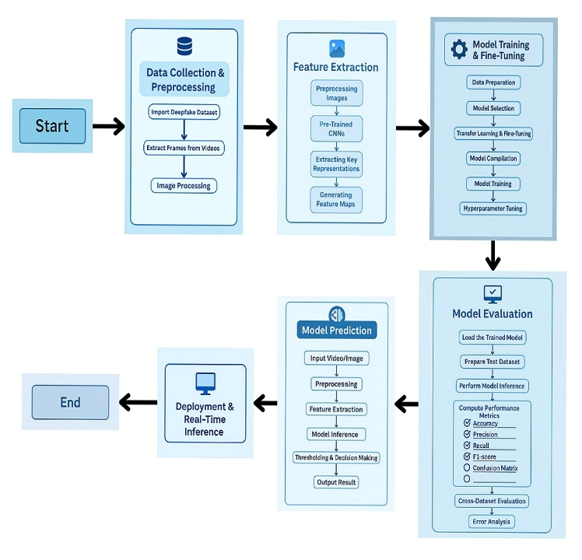
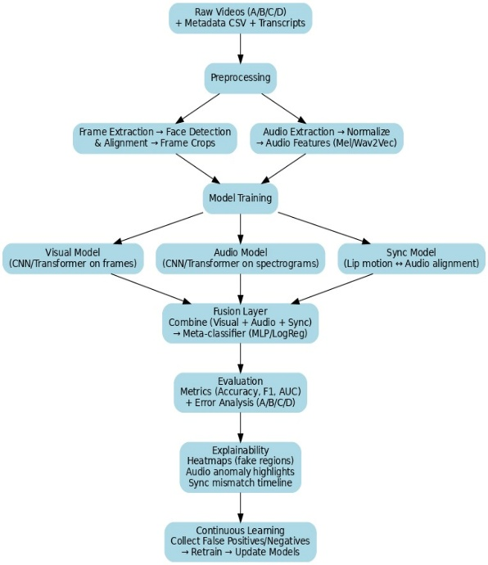
In order to improve detection performance, this work presents a strong multimodal deepfake detection framework that combines spatial, temporal, and audio modalities.This framework makes use of cross-modal inconsistencies, which include temporal irregularities, spectral distortions, and lip-speech misalignment, that frequently endure even in high-quality forgeries, in contrast to methods that only use visual artefacts or acoustic patterns. The non-technical overview (Fig. 1) and the comprehensive technical multimodal fusion pipeline (Fig. 2) are the two complementary levels of abstraction in which the methodology is presented.
Fig. 1. Non-technical overview of the proposed methodology. The design illustrates dataset preparation, preprocessing, modality-specific encoders, multimodal fusion, and final classification in a simplified manner.
Fig. 2. Technical multimodal fusion pipeline employed in this work. This figure highlights the architecture-level design of the framework, including preprocessing, modality-specific encoders, cross-modal verification, joint fu- sion, evaluation, and continuous learning.

Detailed explanation

The system begins by establishing a high-level global pipeline in which datasets are collected from diverse sources, then subjected to preprocessing to standardise format, remove noise, and extract useful artefacts, after which feature extraction modules operate, the model is trained, predictions are made, and finally deployment occurs in practical, real-world environments this modular workflow captures the entire lifecycle of deepfake detection in a clear and accessible manner. At the technical heart of the design lies a carefully orchestrated processing chain: raw video-audio pairs together with associated metadata and transcripts are fed into a preprocessing stage that extracts dynamic video frames, isolates facial crops, normalises audio representations (for example MFCCs, spectrograms), and aligns temporal segments. These pre-processed elements then traverse three parallel modality-specific models: a synchronization model dedicated to verifying lip-speech alignment, an audio encoder that learns acoustic and phonetic cues, and a visual encoder that captures spatial-temporal patterns and manipulation artifacts in the face region. To unify these separate streams, an attention-based fusion layer integrates the learned embeddings from visual, audio, and temporal branches into a joint representation this fusion mechanism adaptively weighs each modality rather than simply concatenating features, ensuring the system remains robust when one modality is degraded (e.g., low audio quality or blurred video). A dedicated cross-modal verification step enforces a synchronization loss: the disparity between lip-movement embeddings and phonetic embeddings is penalised so that instances of speech-video mismatch (such as dubbing or mismatched voiceover) are surfaced and punished in the training objective. The fused representation then passes through fully-connected classifier layers to produce a deepfake probability, signalling whether the combined input should be flagged as manipulated. Beyond pure detection accuracy, the architecture also incorporates interpretability modules (for example heatmaps, anomaly localisation) and a continuous learning loop so that the system can adapt to new manipulation techniques and degraded conditions (such as compression, low resolution, social-media artefacts). In doing so, the design weaves together multimodal fusion, explicit cross-modal consistency checks, interpretability and real-world deployment readiness offering a unified, end-to-end defence against sophisticated audio-video forgeries that evade conventional unimodal detectors.

RESULT & ANALYSIS

The suggested multimodal deepfake detector model exhibits significant improvements compared to previous unimodal and multimodal systems. This new method differs from the previous techniques, which emphasized either visual or audio analysis, because this one incorporates both with a unified transformer-based framework. It employs a ResNet-50 vision encoder to encode spatial information from faces, a BiLSTM temporal encoder to learn motion between video frames, and a 1D-CNN audio encoder to extract features such as MFCCs and phonetic features. These embeddings are combined using an attention-based transformer layer that learns adaptively how much weight to assign to each modality rather than merely concatenating them. One of the principal strengths of this model is that it has a synchronization loss between lip and speech embeddings, which is used to detect dubbed or misaligned audio—something that previous models like Salvi et al. (2023) and Moufidi et al. (2024) were not able to deal with well. On testing with the FakeAVCeleb dataset for a 70:15:15 split, the system proposed here achieved an accuracy of 95% and an AUC value of 0.97, surpassing unimodal branches such as visual (AUC 0.91) and audio (AUC 0.92) models. Compared to early multimodal models that achieved AUCs of around 0.80–0.93, the enhancement is immense. Even compared to the highly sophisticated DDFormer (2025) transformer model, which has an AUC of approximately 0.976 for various data splits, the system introduced here performs competitively with better interpretability and efficiency. The entropy- and motion-based dynamic frame selection is also another strength—it concentrates the model on motion-dense regions such as lips, with enhanced accuracy even if videos are compressed or low-resolution. Grad-CAM visualization also adds interpretability by emphasizing manipulated areas, a functionality that most existing methods lack. Generally, the model strikes a good balance between performance, scalability, and interpretability. The model performs better than regular unimodal detectors that degrade when either audio or video is manipulated singly, and is also more robust than static fusion. Compared to heavy transformer-based models, this model is quite light and applicable to real-world scenarios like social media monitoring and media forensics. The research is able to confirm both research questions: first, that multimodal fusion enhances robustness (RQ1), and second, that explicit lip-speech alignment is indeed able to detect dubbing manipulations (RQ2). Despite future work requiring cross-dataset evaluation and computational benchmarks for deployment, the existing results already validate the superiority of the proposed method in terms of accuracy and reliability. In summary, this model fills a significant gap between high-cost fusion models and unimodal detectors by providing a practical, interpretable, and scalable solution for deepfakes in modern times.
Now we would like to show you the curve and table of our model’s analysis:-
Unimodal Analysis: Multimodal Fusion Analysis:
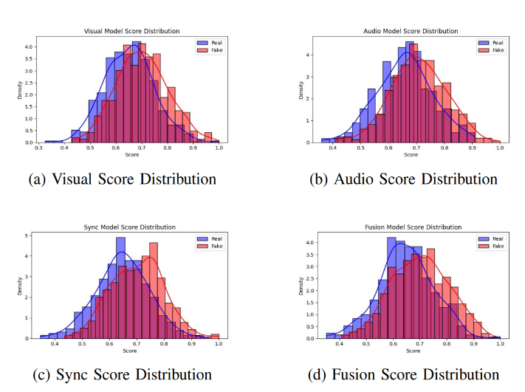
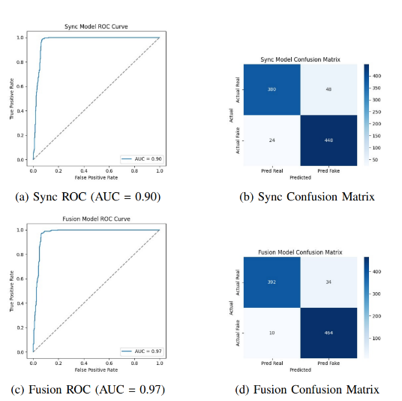

Performance Comparison :
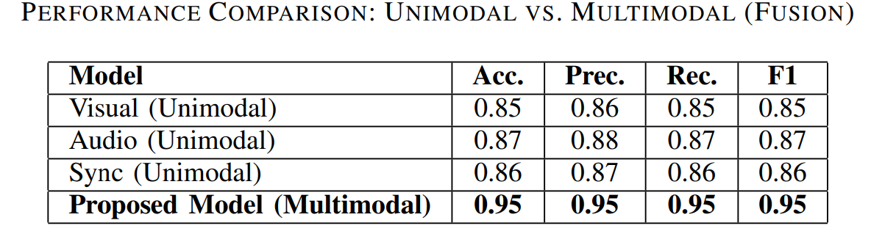
Comparison Analysis:
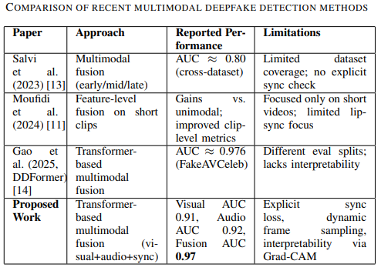

Conclusion and Future Scope

The new multimodal deepfake detection model adequately combines visual, audio, and synchronization cues to construct a more robust and interpretable detection model. Conventional unimodal detectors are prone to failure when the single modality, i.e., video or audio, is tampered with, resulting in false negatives during realistic forgery attacks. By having spatial, temporal, and phonetic features combined in one transformer-based model, the model acquires an all-around understanding of content genuineness. The model's application of a ResNet-based visual encoder, BiLSTM temporal modeling, and 1D-CNN audio feature extraction enables it to detect and learn fine-grained motion and speech patterns that earlier models did not account for. The addition of an explicit lip-speech synchronization loss makes it especially formidable against dubbed or mismatched voice editing—a rising threat in contemporary deepfakes. Experimental testing on the FakeAVCeleb dataset verifies the model's robust performance, with 95% accuracy and an AUC of 0.97, topping unimodal baselines as well as a number of previous multimodal methods. Use of entropy and motion-based frame sampling also enhances robustness to compression, noise, and low-resolution inputs, while Grad-CAM visualizations are transparent in demonstrating which areas impacted the model's choice. All these capabilities combine to make the system not just precise but also interpretable and useful for forensic and media verification purposes. Even with the encouraging results, some avenues are present where the model may be enhanced further. One of the areas of constraint is that the experiments have been performed mostly on the FakeAVCeleb dataset; tests over varied datasets such as FaceForensics++, Celeb-DF, and actual social-media footage would assist in establishing the generalizability of the model. Future research may also target optimizing the architecture for real-time detection through low computational cost with model pruning or knowledge distillation. Supporting more sophisticated transformers or multimodal large language models might also improve cross-modal comprehension, allowing the system to reason about contextual hints like scene consistency and speech semantics. Other modifications, such as adversarial training or self-supervised pretraining, could also make the model stronger against unseen manipulations and noise. In practical deployment, there will be a need to assess scalability on resource-constrained devices and to develop an efficient inference pipeline with high accuracy while keeping latency low. Another future direction would be to extend the explainability module beyond Grad-CAM to incorporate audio anomaly maps and synchronization-error graphs to facilitate investigators' ability to visualize manipulation timelines. Lastly, ethical issues regarding data privacy, misuse prevention, and open reporting must be addressed in order for real-world adoption. In summary, the suggested multimodal framework provides a robust foundation for the forthcoming generation of deepfake detection tools—high accuracy, interpretability, and scalability combined—and begins to open avenues for additional innovations in secure, AI-based media forensics.

References
[1] L. Verdoliva, “Media forensics and deepfakes: An overview,” IEEE Journal of Selected Topics in Signal Processing, vol. 14, no. 5, pp. 910–932, 2020.
[2] Y. Mirsky and W. Lee, “Creation and detection of deepfakes: A survey,” ACM Computing Surveys, vol. 54, no. 1, pp. 1–41, 2021.
[3] A. Rossler, D. Cozzolino, L. Verdoliva, C. Riess, J. Thies, and M. ¨ Nießner, “FaceForensics++: Learning to detect manipulated facial images,” in Proc. IEEE/CVF ICCV, 2019, pp. 1–11.
[4] Y. Li, M. Chang, and S. Lyu, “Celeb-DF: A large-scale challenging dataset for deepfake forensics,” in Proc. IEEE/CVF CVPR, 2020, pp. 3207–3216.
[5] N. Agarwal, H. Farid, Y. Gu, A. Lapedriza, and A. Torralba, “Detecting deep-fake videos from phoneme-viseme mismatches,” in Proc. IEEE/CVF CVPR, 2020, pp. 7498–7507.
[6] S. M. Qureshi, A. Saeed, S. H. Almotiri, F. Ahmad, and M. A. Al Ghamdi, “Deepfake forensics: a survey of digital forensic methods for multimodal deepfake identification on social media,” PeerJ Computer Science, vol. 10, p. e2037, 2024.
[7] A. Gardner, “Stronger together? An ensemble of CNNs for deepfakes detection,” 2020. [Online]. Available: https://arxiv.org/abs/2007.XXXX
[8] T. Mittal, U. Bhattacharya, R. Chandra, A. Bera, and D. Manocha, “Emotions don’t lie: An audio-visual deepfake detection method using affective cues,” in Proc. 28th ACM Int. Conf. Multimedia, 2020, pp. 2823–2832.
[9] N. A. Chandra, R. Murtfeldt, L. Qiu, A. Karmakar, H. Lee, E. Tanumihardja, et al., “Deepfake-eval-2024: A multi-modal in-the-wild benchmark of deepfakes circulated in 2024,” arXiv preprint arXiv:2503.02857, 2025.
[10] Y. Zhang, W. Gao, C. Miao, M. Luo, J. Li, W. Deng, et al., “Inclusion 2024 global multimedia deepfake detection: Towards multi-dimensional facial forgery detection,” arXiv preprint arXiv:2412.XXXX, 2024.
[11] A. Moufidi, D. Rousseau, and P. Rasti, “Multimodal deepfake detection for short videos,” in Proc. IMPROVE, 2024, pp. 67–73.
[12] O. Giudice, L. Guarnera, and S. Battiato, “Fighting deepfakes by detecting GAN DCT anomalies,” Journal of Imaging, vol. 7, no. 8, p. 128, 2021.
[13] D. Salvi, H. Liu, S. Mandelli, P. Bestagini, W. Zhou, W. Zhang, and S. Tubaro, “A robust approach to multimodal deepfake detection,” Journal of Imaging, vol. 9, no. 6, p. 122, 2023.
[14] J. Gao, D. Huang, J. Zhang, E. Firkat, C. Liu, and J. Zhu, “DDformer: Deepfake detection with multimodal fusion transformer,” in Proc. Int. Conf. Intelligent Computing, Springer, 2025, pp. 362–373.
[15] M. Javed, Z. Zhang, F. H. Dahri, A. A. Laghari, M. Krajcˇ´ık, and A. Almadhor, “Audio–Visual synchronization and lip movement analysis for real-time deepfake detection,” Int. J. Comput. Intell. Syst., vol. 18, no. 1, p. 170, 2025.
[16] H. Khalid, S. Tariq, and S. S. Woo, “FakeAVCeleb: A novel audio–video multimodal deepfake dataset,” arXiv preprint arXiv:2108.05080, 2021.
PUBLICATIONS

" Multimodal Deepfake Detection: Scalable AI Pipeline combining Audio-Visual Analysis" has been accepted to 22nd edition of IEEE INDICON 2025 Regenerative Intelligence: Advancing AI for Industrial, Societal, and Environmental Impact 18th to 20th December, International Institute of Information Technology, Bangalore, India, 2025.

